**Embedded System Lab (CS-16203)**

**Assignment –02**

1. Write an assembly program to print the sum of first “N” natural numbers. Ex: N=5, Sum=1+2+3+4+5=15

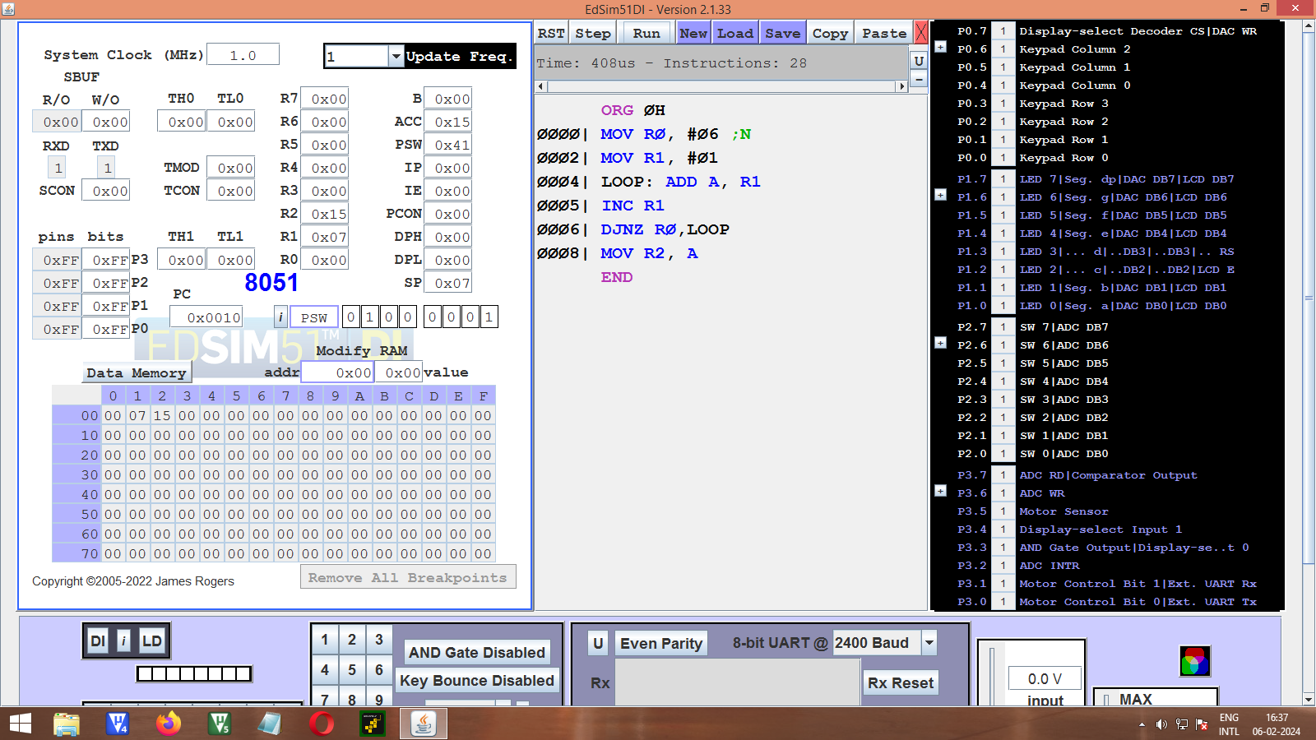

2. Write an assembly language program to check whether the given number is EVEN or ODD.

ORG ØH

MOV A, RØ

MOV B, #Ø2

DIV AB

MOV A,B

JZ EVEN

MOV R1, #01H

SJMP TERM

EVEN: MOV R1, #ØH

TERM: NOP

ENDS

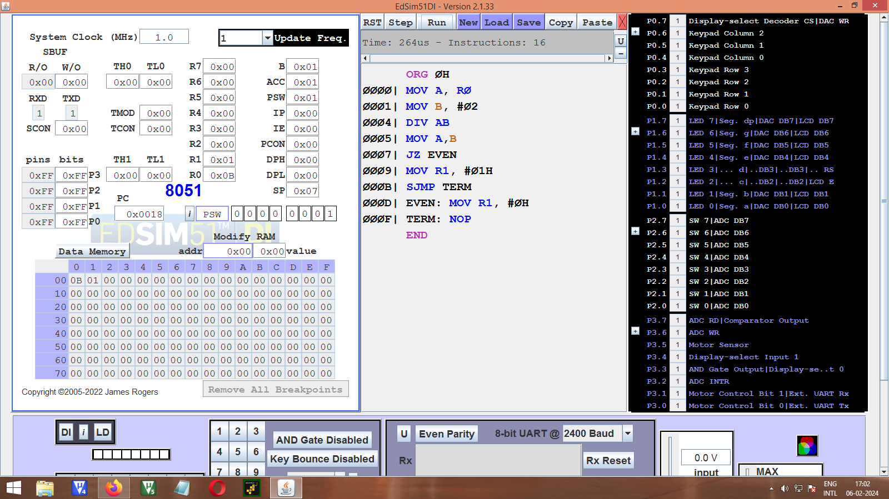

3. Implement an assembly language program to print the sum of the numbers given in an Array.

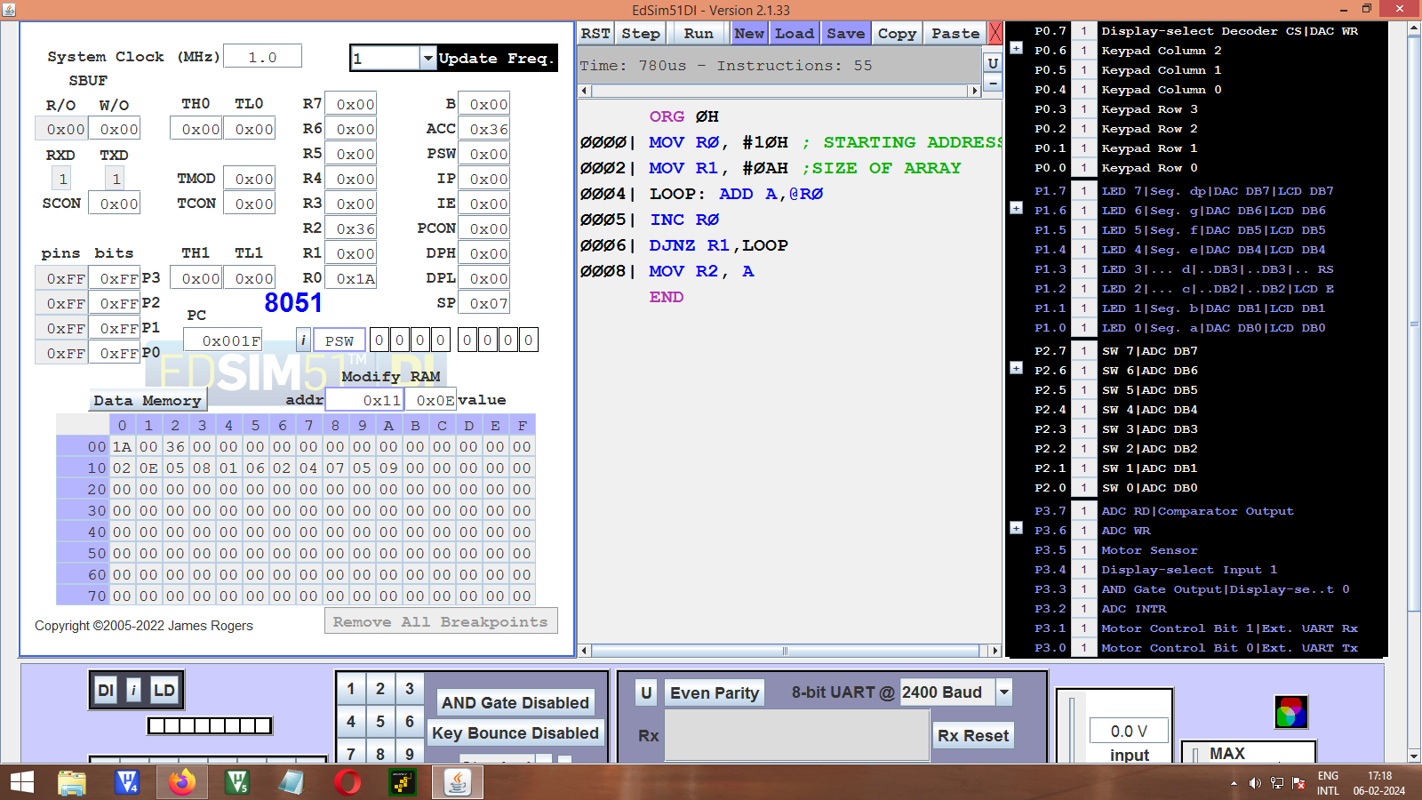

4. Write an assembly language program to print the sum of all even numbers less than “N”, where “N” is a given positive number.

ORG ØH

MOV RØ, #ØØH

MOV A, #ØAHN

MOV B, #02H

DIV AB

MOV R1, ANO OF EVEN NO.

MOV A, B

JZ SKIP

INC R1

SKIP: CLR A

; ADD

LOOP: ADD A, RØ

INC RØ

INC RØ

DJNZ R1, LOOP

MOV R2, A

END

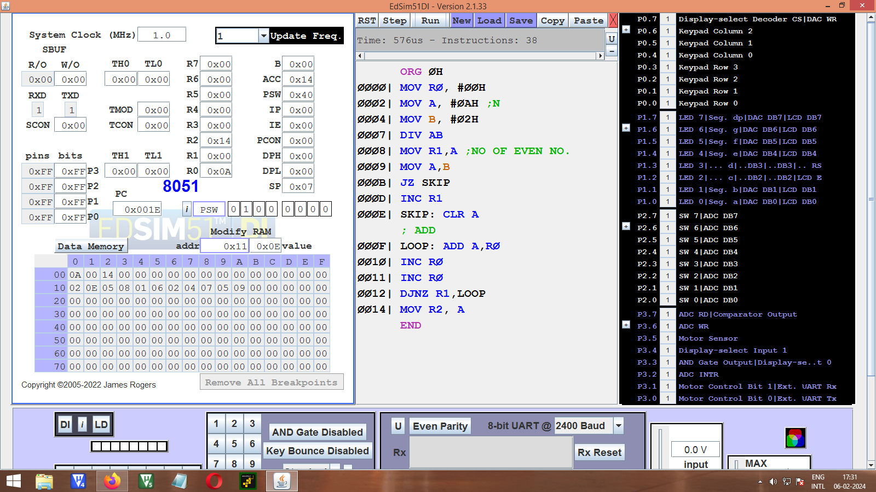

5. Write an assembly language program for addition, subtraction and multiplication of two 16 bit numbers.

ADDITION:

ORG ØH

1ST NO

MOV R2, 2ØH

MOV R3, 21H

2ND NO

MOV R4,23H

MOV A,24H

ADDITION

ADD A,R3

MOV 32H, A

MOV A,R2

ADDC A,R4

MOV 31H, A

JNC SKIP

MOV 30H, #01H

SKIP:

END

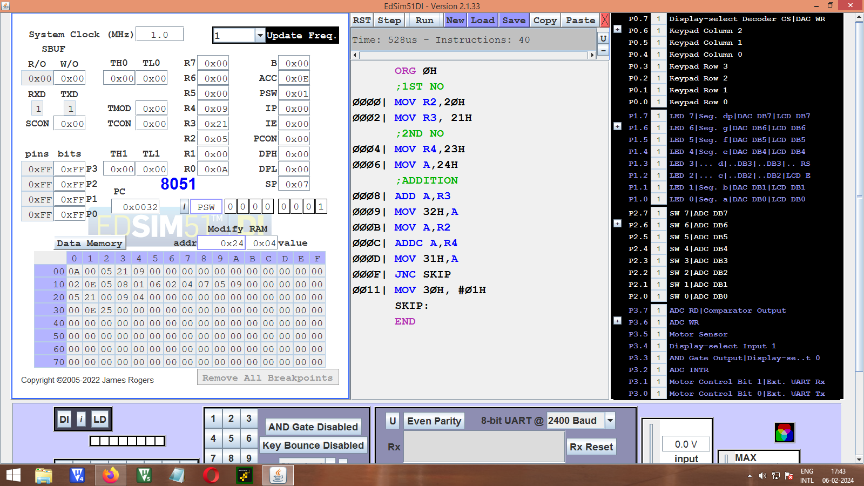

SUBTRACTION:

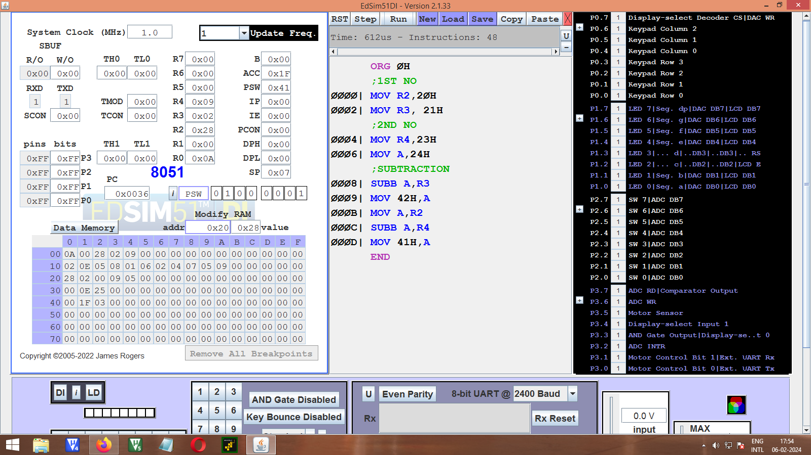

MULTIPLICATION:

ORG ØH

;1ST NO

MOV R2, 20H

MOV R3, 21H

; 2ND NO

MOV R4,23H

MOV A, 24H

;MULTIPLICATION

MOV B,R3

MUL AB; LSB1 LSB2

MOV 43H, BLAST 8 LSB

MOV RØ, A

MOV B, R2

MOV A, 24H

MUL AB; LSB1*MSB2

MOV R1, A

MOV A, B

ADD A,RØ

MOV RØ, A

MOV B,R3

MOV A,R4

MUL ABMSB1*LSB2

MOV R5, A

MOV A, B

ADDC A, RØ

MOV 42H, A 2ND LAST 8 LSB

MOV A,R5

ADDC A, R1

MOV R1, A

MOV B, R2

MOV A,R4

MUL ABMSB1*MSB2

MOV RØ, A

MOV A, B

ADDC A, R1

MOV 41H, A 2ND 8 MSB

CLR A

ADDC A,RØ

MOV 40H, A1ST 8 MSB

END

